Module: CSCU9A3
Assessment: Main Assignment
Due Date/Time: 4pm 28 November
AIAS Levels Allowed: AI Planning

 | Please tick the boxes/include appropriate information below
Student ID Number | 3602825
Word Count (no limit) | 1100-1200
I have read and understand the severity of academic misconduct – see link below
I give consent for my work to be used as an exemplar to future students.
I have checked my submitted document to ensure it complies with module requirements.
Link to version-controlled file (i.e on OneDrive, Google Docs, Github, or other) which contain evidence of the process I undertook to complete this assignment.  Information on how to create a Microsoft 365 OneDrive folder is available HERE.  *Please see notes below | Github
I understand that failure to provide a working, and populated, OneDrive link, or equivalent, means that my grade may be withheld – see link below – please tick the box. | - ☐
Tailored feedback.
If you would like tailored feedback on a specific aspect (or aspects) of your work (e.g., referencing, writing style, grammar), then please give details here.
If you used AI at (or below) the level allowed, please explain briefly which AI, how you used it, and for what purpose. | Level 2: Ai Planning,
*This may include (but is not limited to) drafts, versions of the finished document, notes, references, AI output, and AI prompts. These materials are not marked or graded, but they are simply a way to demonstrate how your work was created and to confirm that any AI use in your final submission is within the permitted AIAS scale for your assessment. Providing this helps safeguard you, showing your authentic process, and protecting you should any academic integrity questions arise.
https://www.stir.ac.uk/about/professional-services/student-academic-and-corporate-services/academic-registry/policy-and-procedure/

Report for CSCU9A3 assignment
Binary Tree class
Task 1
So I started with the binary tree program, and made a few changes in the class as follow. Firstly I refactored the ‘Find Method’. In figure 1.1 we can see that I added a null check to prevent runtime errors and then altered the comparison from getNodeObjectName() to getFullName() for easy understanding. I made it case insensitive. Finally theres an improved recursion logic for left and right traversal.

[Figure 1.0, starter code]
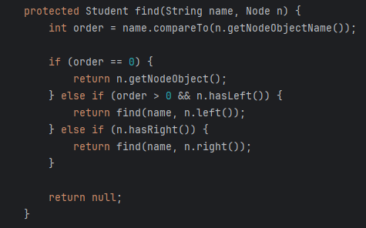
[Figure 1.1, refactored code]
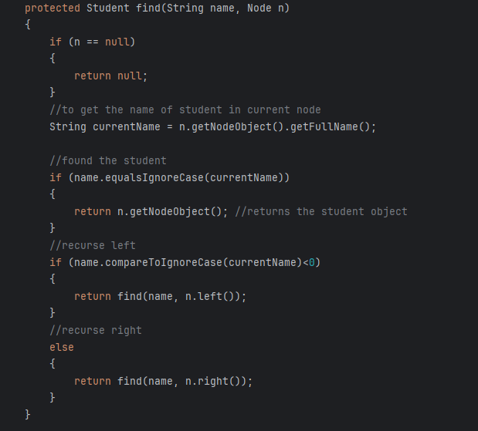

Task 2
I implemented orderWalking as you can see in figure 1.2. In this the traversal logic for inOrder was constructed such that it followed the standard binary tree traversal pattern. The method begins by visiting the left child of the current node, then processes the node, and finally moves to the right child. This is to ensure that the nodes are accessed in the naturally sorted order. To capture the names of the nodes during traversal, the method uses the getFullName() function, which retrieves the full name of the object stored in each node.
[Figure 1.2.]
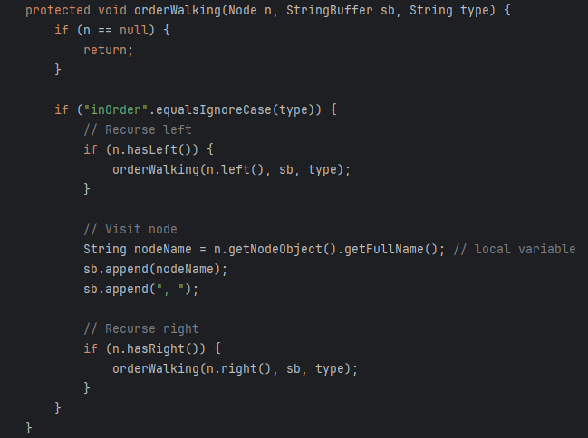

Task 3
Next I implemented another method called ownWalking (figure 1.3) to walk through the tree in a different way. Instead of visiting the current node first, the method goes to left and right children first and then to the node. This changes the order of appearance of the names. I used getFullName() to collect each name.

[Figure 1.3]
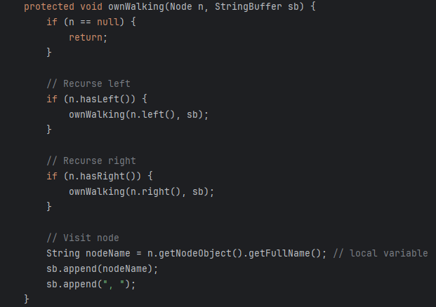

University Class:
Task 1

[Figure 2.0, starter code]
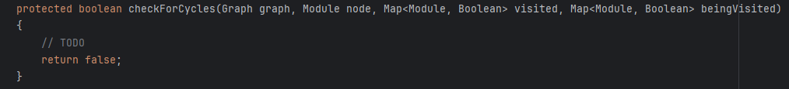
[Figure 2.1, refactored code]
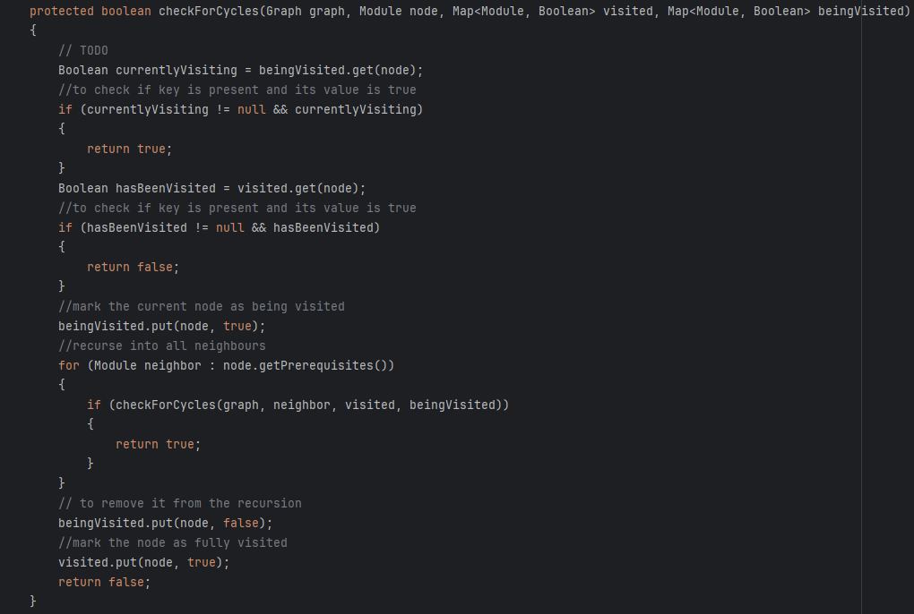
In starter code the as you can see (figure2.0) there is no logic and an empty method. I added full logic to check for cycles in the graph (figure 2.1). Now, it marks the nodes as “being visited” and looks at prerequisites. If a node is found again while being visited it means theres a cycle. After finishing its marked as visited.

Task 2
[Figure 2.2, starter code]
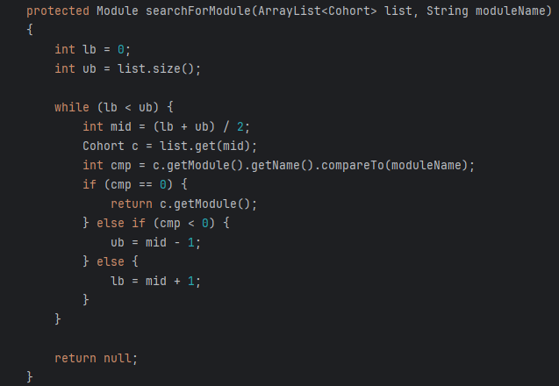
[Figure 2.3, refactored code]
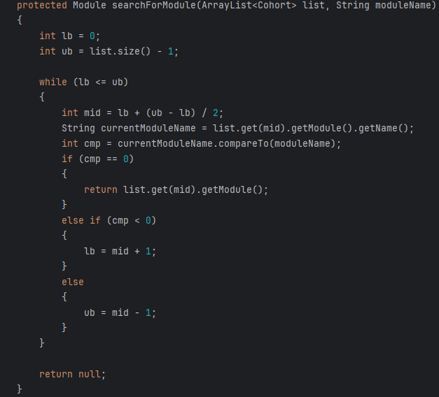
The starter code had mistakes in the binary search. It used wrong bounds and could miss modules. In the refactored code I fixed the bounds and changed the loop.

Task 3
[Figure 2.4, starter code]
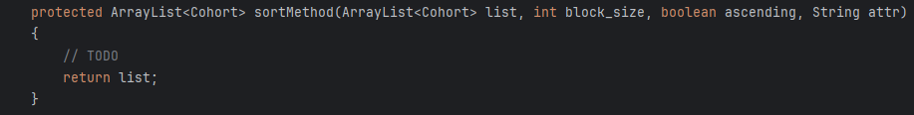
[Figure 2.5, refactored code] 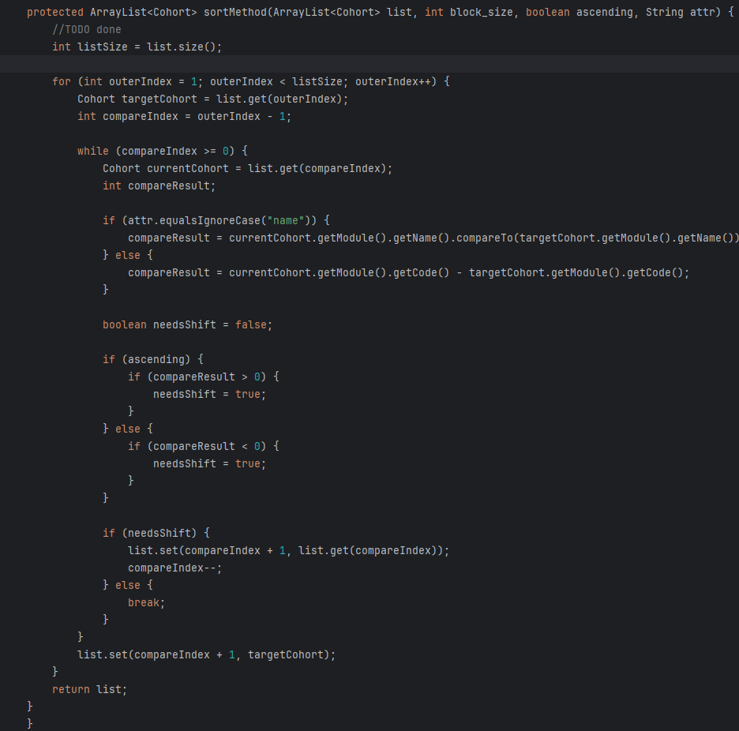
In the edited code, I wrote an insertion sort that can sort cohorts by either module code or name. It supports ascending and descending order. This means list of cohorts can now be arranged properly based on the seleccted attribute.

University Test Class
Task 1
[Figure 3.0, starter code]
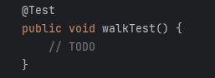
[Figure 3.1, refactored code]
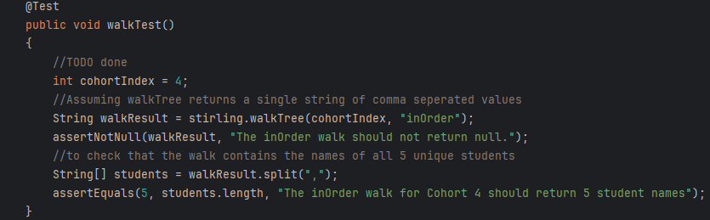
In this the starter code(figure 3.0) had no implementation at all. My refactored (figure 3.1) code tests the walkTree method by checking that the result is not null and contains the expected amount of student name. This confirms the correct working of tree walk.

Task 2
[Figure 3.2,starter code]
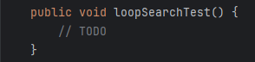
[Figure 3.3, refactored code]
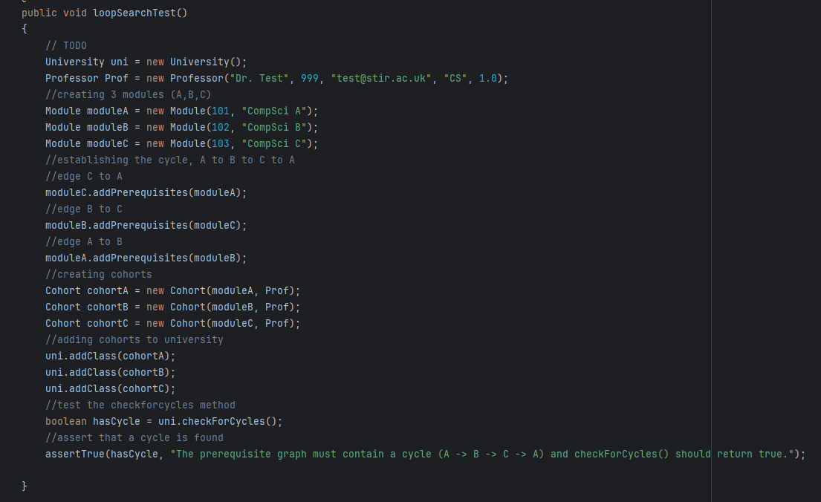
In this also, the method was empty. My edited version created 3 modules with a cycle and checks if the program detects it. This proves the working of the cycle detection.

Task 3
[Figure 3.4, starter code]
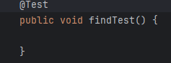
[Figure 3.5, refactored code]
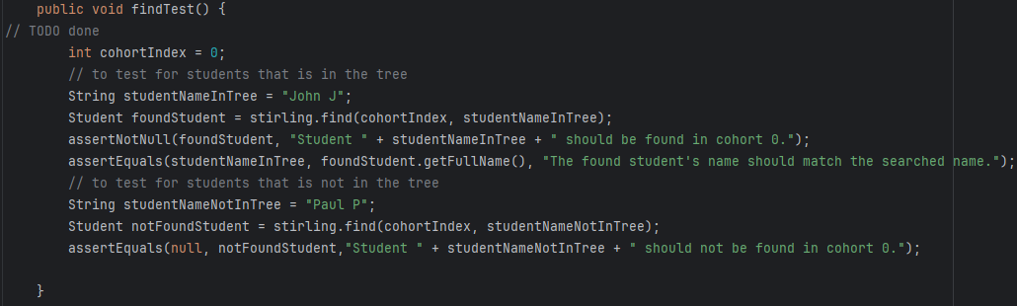
Here the starter code method was empty as well. And the refactored one checks that a student who exists is found and student which doesn’t exist is not found. This shows the find method works.

Task 4
[Figure 3.6, starter code]
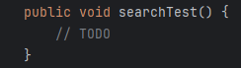
[Figure 3.7, refactored code]
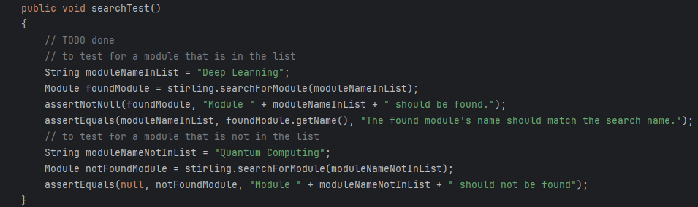
Here as well the starter code was empty. The refactored code checks that searching for a real module works and searching for a fake one returns null. This proves working of search method.

Task 5
[Figure 3.8, starter code]
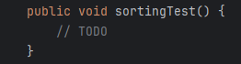
[Figure 3.9, refactored code]
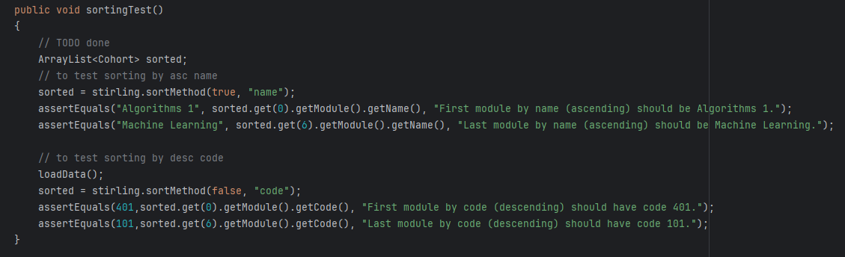
Here the starter code was empty as usual. The refactored code will check sorting by name(ascending) and by code(descending). This confirms the working of sort method.

Task 6
[Figure 3.10, starter code]
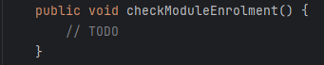
[Figure 3.11, refactored code]
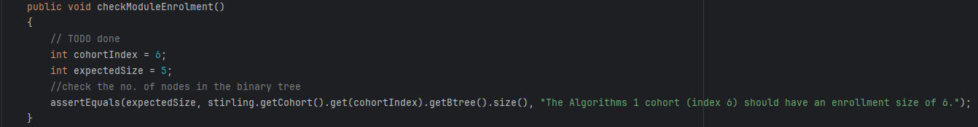Here the starter was empty again and the refactored code checks whether the “Algorithms 1” cohort has proper 5 students. This proves enrolment size is correct.

Student/Professor/NewStudent class
Task 1
And after that I moved to the Student and Professor class. In that there were a lot of lines of code that were repeated which included full name, registration, number and also email. A few more lines containing getter and setter methods, so to make the professor and students code cleaner, I created another class. A parent class called NewStudents, which has the necessary lines of code to avoid repetition which can be observed in figure 4.0.
z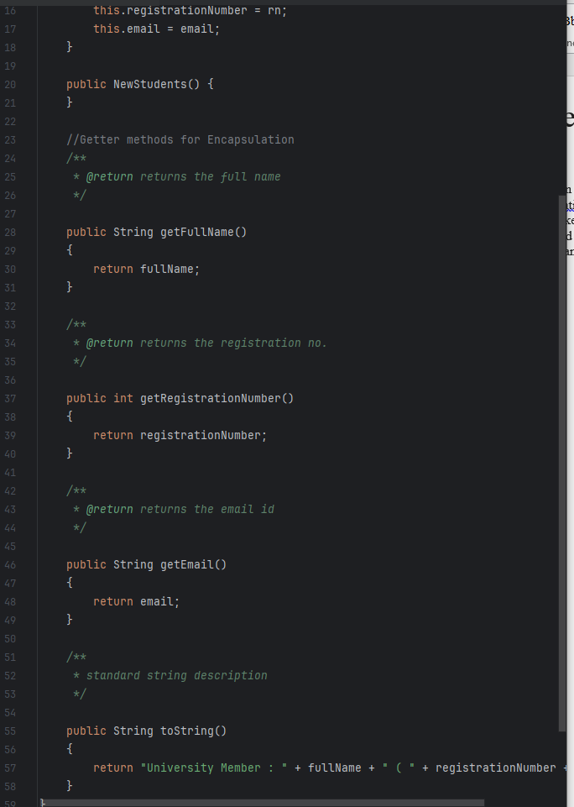
All that was done to refactor the code was to get all of the repeated lines/statements into this parent class called NewStudents. And when I extend it to professor and student classes, theres no more complication or repetition of code.

Summary of the Assignment
This assignment was way more tough compared to p1 and p2 but it was a good learning lesson for me. Learning how binary trees work and how different traversals work was confusing at first but after a while I started understanding it. Debugging was more to a fun side as it showed me if my code was working or not. Sorting gave me a little difficulty in the beginning but after trial and error it worked. Some of the parts were tricky but those lecture knowledge helped me keep up. Overall, this assignment was tough but helped me get some beneficial knowledge.

